Ann Ly’s MIXCR Start Tool
Ann Ly
8/17/26

Please view this document using “Web Layout” in Microsoft Word.
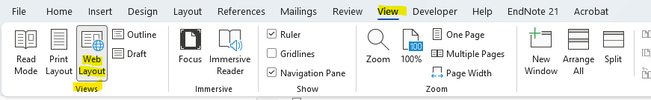

Table of Contents

Overview
Background Biology
Preparing for Analysis
Get a MIXCR License
Create Input Files and Specify your Directories
Option 1: Minimal Coding Method
▶️1. Run the MIXCR Start Tool
1. Make_Folders
2. Sample_Names
3. Fastq_dir
4. Out_dir
5. B_dir
6. Specify FASTQ Format
7. Ready to Go
▶️2. Verify that all files are there using “tree”
▶️3. Run the Commands specific to MIXCR
1. Run MIXCR
2. Run MIXCR Export
▶️4. MIXCR is Done! Your outputs will be at out_dir and b_dir that you specified.
▶️5. Optional: Place the data in a readable way
1. Add helper files and folders
2. Merge IGH, IGK, and IGL into the same table
⚠️Troubleshooting Missing Files
Results Interpretation
___
Option 2: Pure Coding Method for the Start Tool
▶️1. Initialize Script
Run Initialize Script
OR Alternative to Initialize Script
1. Make MIXCR Analyze Commands
2. Edits the Template Scripts
01. Template for MIXCR Analyze
02. Template for MIXCR Export
▶️2. Run the Commands
▶️3. MIXCR is Done! Your outputs will be at out_dir and b_dir that you specified.
___
Other Useful Information
Key MIXCR Commands
Core Parts of my MIXCR Start Tool

Overview

MIXCR has proved very useful for our lab.
We can gauge IGHV status for patients and check for light chain usage.
It’s also a good control to prevent sample mix-ups.

Background Biology

There Are 3 IGH, IGK, and IGL Loci that help build antibodies
These are heavy, kappa, lambda loci (H, K, L) in the genome
- H: Encodes Heavy chain
  - Contains V, D, J, C locus
- K and L: Encodes light chain → no D locus.
  - Kappa
    - Contains V, J, C locus
  - Lambda
    - Contains V, J, C locus

The C locus in heavy chain is special because it helps define isotype.
Antibodies are made of heavy chains and light chains
- Heavy chains define the isotype → IgA, IgM, IgD, IgE, IgG
  - Made up of constant regions that define isotype
  - V, D, J
- Light chains
  - Made up of Kappa OR Lambda
  - V, J only

Preparing for Analysis

Get a MIXCR License
Guide from https://hpc.nih.gov/apps/mixcr.html

- Get license code from https://platforma.bio/mixcr-access. You will need a “Free Academic License."
  - For example, mine looked like this
  - E-OMZQAHFCCTXNBKBTQFIVVPFXYAOCDHAGMCKCEVJAXJWQKRSU
- Put mi.license content to MI_LICENSE global variable by adding the following line in ~/.bashrc file:
  - export MI_LICENSE="CopyPasteLicenseKeyHere"
  - make sure to remove all old license info:
    - rm ~/.mi.license
    - rm ~/mi.license
    - unset MI_LICENSE_FILE

~/.bashrc is like a universal settings file for your Biowulf
Paste this line in your ~/.bashrc file.
You can do this by typing “nano ~/.bashrc” to edit your ~/.bashrc.

export MI_LICENSE="E-OMZQAHFCCTXNBKBTQFIVVPFXYAOCDHAGMCKCEVJAXJWQKRSU"

My BASHRC then contains the license!

# .bashrc

# Source global definitions
if [ -f /etc/bashrc ]; then
. /etc/bashrc
fi

# User specific environment
if ! [[ "$PATH" =~ "$HOME/.local/bin:$HOME/bin:" ]]
then
PATH="$HOME/.local/bin:$HOME/bin:$PATH"
fi
export PATH

export MI_LICENSE="E-OMZQAHFCCTXNBKBTQFIVVPFXYAOCDHAGMCKCEVJAXJWQKRSU"

# Uncomment the following line if you don't like systemctl's auto-paging feature:
# export SYSTEMD_PAGER=

# User specific aliases and functions
#export R_LIBS_USER="/data/lyat/R/4.5" --> commented out 4/2/26 because I want R per version

# --> commented out on 4/2/26 to prevent issues
# >>> conda initialize >>>
# !! Contents within this block are managed by 'conda init' !!
#__conda_setup="$('/usr/local/Anaconda/envs/py3.10/bin/conda' 'shell.bash' 'hook' 2> /dev/null)"
#if [ $? -eq 0 ]; then
# eval "$__conda_setup"
#else
# if [ -f "/usr/local/Anaconda/envs/py3.10/etc/profile.d/conda.sh" ]; then
# . "/usr/local/Anaconda/envs/py3.10/etc/profile.d/conda.sh"
# else
# export PATH="/usr/local/Anaconda/envs/py3.10/bin:$PATH"
# fi
#fi
#unset __conda_setup
# <<< conda initialize <<<

If you already have a license, activate it by typing this into biowulf:

mixcr activate-license

Create Input Files and Specify your Directories
You will need this information in order to run MIXCR

Make new locations to place the MIXCR results  Make the directories you want, then use PWD to retrieve the locations of these directories. | out_dir | MIXCR Analyze Output directory.  - This is the first place MIXCR places its analysis output.  - Use PWD to report where this directory lives!
 | b_dir: | MIXCR Export directory.  - After running MIXCR analyze, we only want to retrieve IGHV. This is where the human readable MIXCR results will live  - Use PWD to report where this directory lives!
Information about your FASTQ files | fastq_dir: | The location of all your FASTQ files.
 | sample_names: | the list of all your FASTQ file names.
 | FASTQ R1 style | FASTQ files should be in NAME_R1.fastq.gz and NAME_R2.fastq.gz format.  - This means that each file ends with _R1.fastq.gz and _R2.fastq.gz.  - Other formats can exist too for the suffix. Make sure you record what the suffixes are!
 | FASTQ R2 style

In other words, you should write down something that looks like this for your own reference:

b_dir
/data/lyat/projects/project001/mixcr/set01/special_project_name/02_b_chain

fastq_dir
/data/lyat/projects/project001/fastq/01_lymph_node/special_project_name/01_fastq_gz/special_project_name

out_dir
/data/lyat/projects/project001/mixcr/set01/special_project_name/01_out

sample_names
"S1","S2","S3","S4","S5","S6","S7","S8","S9","S10","S11","S12","S13","S14","S15","S16","S17","S18","S19","S20","S21","S22","S23","S24","S25","S26","S27","S28","S29","S30","S31","S32","S33","S34","S35","S36","S37","S38","S39","S40","S41","S42","S43","S44","S45","S46","S47","S48","S49","S50","S51","S52","S53","S54","S55","S56","S57","S58","S59","S60","S61","S62","S63","S64","S65","S66","S67","S68","S69","S70","S71","S72","S73","S74","S75","S76","S77","S78","S79","S80","S81","S82"

FASTQ R1 style: _R1.fastq.gz
FASTQ R2 style: _R2.fastq.gz

For sample_names: Prepare your list of FASTQ names in a very specific way
The names should be in list format, with quotation marks surrounding each one.
You can convert a column from Excel to this format by using
https://convert.town/column-to-comma-separated-list
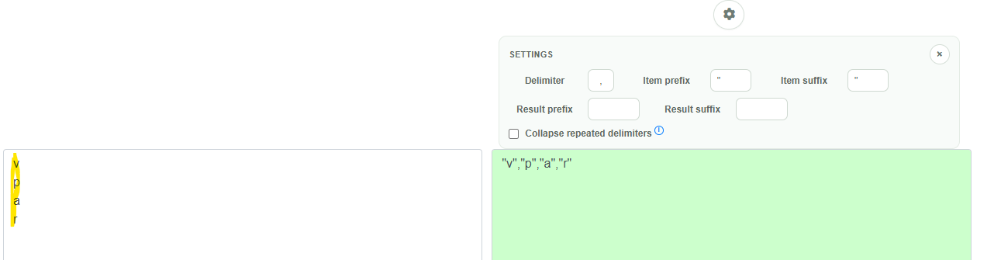
Specify the comma as delimiter and simple quotation marks ("") for the Item Prefix and Item Suffix.
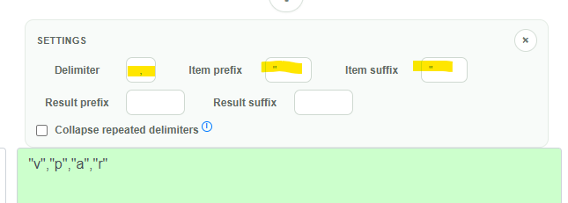

About the Quotations:
They should be this style of quotation (""), not this style (“”). This (“”) style is called “smart quotations” and they will not work in Biowulf!

"S1","S2","S3","S4","S5","S6","S7","S8","S9","S10","S11","S12","S13","S14","S15","S16","S17","S18","S19","S20","S21","S22","S23","S24","S25","S26","S27","S28","S29","S30","S31","S32","S33","S34","S35","S36","S37","S38","S39","S40","S41","S42","S43","S44","S45","S46","S47","S48","S49","S50","S51","S52","S53","S54","S55","S56","S57","S58","S59","S60","S61","S62","S63","S64","S65","S66","S67","S68","S69","S70","S71","S72","S73","S74","S75","S76","S77","S78","S79","S80","S81","S82"

Option 1: Minimal Coding Method

▶️1. Run the MIXCR Start Tool

Download the MIXCR Start Tool that Ann Ly created from
L:\Lab-Wiestner\Ann_Ly\004_special_tools\mixcr_start_tool

Alternatively, you can get it from my Github. This is the faster way.

Downloads the MIXCR Start Tool (by Ann Ly) to your Biowulf space.
Make sure you download the tool near where you will be working with your files.
You can do this by typing into the command line:
git clone https://github.com/atly2000/mixcr_start_tool.git

You will see a new folder in your working directory called “mixcr_start_tool.”
- I refer to this as my “mixcr_start_tool” app.
- Next, enter this folder!

cd mixcr_start_tool

Start the MIXCR Start Tool.
You can do this by typing into the command line:
bash 00_mixcr_start_tool.sh

You will see this menu appear
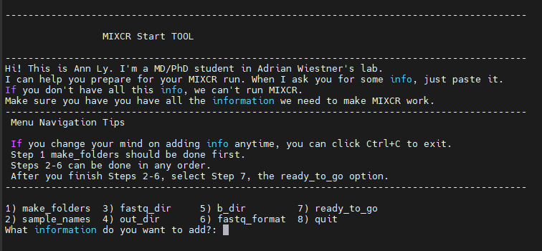

To get ready for MIXCR, you should proceed through each item in the menu from steps 1-6.

1. Make_Folders
When you type “1”, this opens the make_folders option.
It creates the folders that will be used to make the inputs for MIXCR.

Select “y” for yes. Once you do, I’ll make the folders for you.

You will see that new folders appear.

2. Sample_Names
Paste your list of sample names in comma-seperated, quotation marks surrounding each name format.
For example,

"S1","S2","S3","S4","S5"

3. Fastq_dir

Paste the location of your FASTQ files.

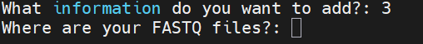

For example, I would paste:
/data/lyat/projects/project001/fastq/01_lymph_node/special_project_name/01_fastq_gz/special_project_name

4. Out_dir
Paste the location where you would like the MIXCR output to go.
For example, I would paste
/data/lyat/projects/project001/mixcr/set01/special_project_name/01_out

5. B_dir
Paste the location where you would like the MIXCR IGH, IGK, IGL output to go.
For example, I would paste
/data/lyat/projects/project001/mixcr/set01/special_project_name/02_b_chain

6. Specify FASTQ Format

Note the extension of your fastq files.
Paste the extension style that they are in when specified.

ex: _1.fastq.gz or _R1.fastq.gz or _1.fastq or _R1.fastq
ex: _2.fastq.gz or _R2.fastq.gz or _2.fastq or _R2.fastq

In my case, I pasted these for each of the styles:
- FASTQ R1 style: _R1.fastq.gz
- FASTQ R2 style: _R2.fastq.gz

7. Ready to Go
Once Steps 1-6 are done, tell me that we are ready to go by selecting option “7”!
This will fully prepare the inputs for MIXCR.

▶️2. Verify that all files are there using “tree”
Type “tree” into the command line.
This list of files will appear! It’s all the files generated by the app so that MIXCR can run.

tree

.
├── 00_mixcr_start_tool.sh
├── input
│ ├── b_dir.txt
│ ├── fastq_dir.txt
│ ├── out_dir.txt
│ └── sample_names.txt
├── prep_scripts
│ ├── 01_mixcr_analyze_script_maker.py
│ └── 02_mixcr_script_maker.py
├── README.md
├── run_scripts
│ ├── 01_mixcr_run.swarm
│ ├── 02_mixcr_export.sh
│ └── swarm_report
└── templates
├── 01_TEMPLATE_mixcr_analyze_script_maker.py
├── 02_TEMPLATE_mixcr_export_script_maker.py
└── extra_scripts
└── make01.sh

▶️3. Run the Commands specific to MIXCR

First, navigate to the run_scripts folder within the mixcr_start_tool folder.

cd run_scripts

1. Run MIXCR
First, we are running the 01_mixcr_run.swarm script, which runs the main MIXCR run.
The status updates will be placed in this “swarm_report” folder, which is within the run_scripts folder.

swarm -f 01_mixcr_run.swarm -t 12 -g 80 --time 24:00:00 --module mixcr --logdir ./swarm_report/

After you hit enter, Biowulf will spit out a number.
Write this number down. This is your JOB_ID, which you will need to monitor the status of the MIXCR run.
- The swarm_report folder contents should share the same JOB_ID as the one that was spit out.
- When you read each status report file, you can see what FASTQ file is being read in that job.
- If you have multiple FASTQ files, the JOB will have many sub jobs ex: _1, _2, _3, etc.
- They are not necessarily following your FASTQ file order. Please read each Job status file to check which FASTQ file is actually being processed by that job.

Notes
- You can change the 24:00:00 to any time you want. 24 hours specified here is sufficient.
- You can also change “t” the threads, from 12 to any number or “g” the gigabytes from 80 to any value you want.
- Go to https://hpcnihapps.cit.nih.gov/auth/dashboard/ to monitor the status of this job.
  - Select “job Info”
  - You can only go to the next step once all associated jobs are “complete.”
  - DO NOT run MIXCR EXPORT if you see any green or red jobs.
  - If jobs are green that means that they are still running.
  - If any jobs turn red, that means they failed. You will have to repeat them alone.
    - This takes some extra scripting.
    - You will have to run that run separately from everyone else, or re-run the entire MIXCR analysis to be safe.
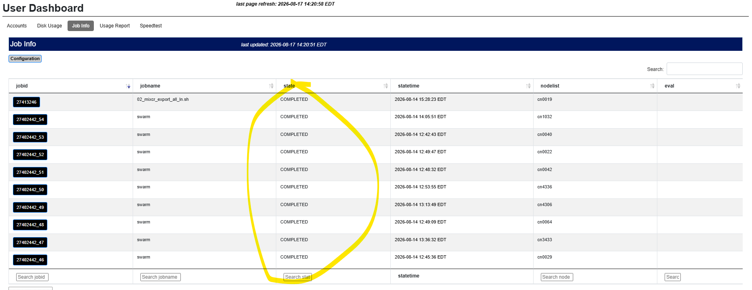

2. Run MIXCR Export
After that first step is done (takes many hours. 5-6 hours), come back to the run_scripts folder and run this.
This should take 2-3 hours at most.
sbatch --mem=10g --cpus-per-task=12 02_mixcr_export.sh
- The status update file will be placed directly into “run_scripts” folder.
- Write this number down. This is your JOB_ID, which you will need to monitor the status of the MIXCR run. The status update file that is created shares this same JOB ID.

▶️4. MIXCR is Done! Your outputs will be at out_dir and b_dir that you specified.

▶️5. Optional: Place the data in a readable way
Run these parts using R.

1. Add helper files and folders
Create a metadata file in .csv format and place it in a folder called “input”
Call it sample_table.csv
It needs 4 columns:
- fastq_id: ID of the FASTQ file
- patient_id: patient or sample ID
- time_point: can also be treatment group, condition etc.
- source_name: unique identifier. Should not have any repeats in this column
  - Create this by merging patient_id column with time_point column.
  - In reality, you can really use any unique combination

I can contain extra columns too. At minimum you need these four.

Upload the contents of the “b_dir” outputs from MIXCR to a folder called “mixcr_output.”
They look something like this.
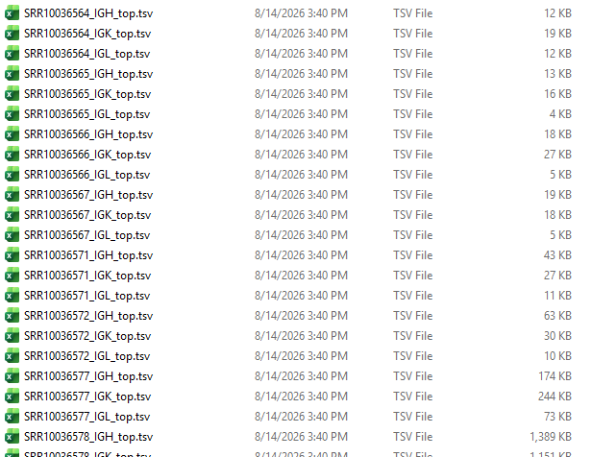

Create a folder called “output.”

The layout of all the files like this
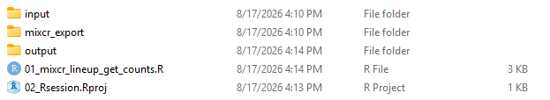

2. Merge IGH, IGK, and IGL into the same table

Run this Rscript, which uses the folders you just made.
The outputs will be in output/ folder.

01_mixcr_lineup_get_counts.R
library(data.table) #to use fread
library(dplyr)
library(tidyr)

#Load Metadata
sample_table <- read.csv("input/sample_table.csv")
fastq_id <- sample_table$fastq_id
sample <- fastq_id

#_________Make the Table of reports__________#
#First, import the .tsv files generated by MIXCR ExportChains
main_dir <- "mixcr_export/"
chains <- c("IGH", "IGK", "IGL")
file_name <- paste0(rep(sample, each=3), "_", chains, "_top.tsv")

#Check for missing files
file_name_long <- paste0("mixcr_export/",rep(sample, each=3), "_", chains, "_top.tsv")
file_status <- file.exists(file_name_long)
missing_files <- file_name_long[!file_status]
print("These files are missing: make dummy files for them:")
print(missing_files)
print("If nothing was listed, ignore this warning.")

file_list <- file_name
cols_keep <- c("readCount","bestVGene","bestDGene","bestJGene","bestCGene","nSeqCDR3","targetSequences")

#Initialize using the first file
countData <- data.frame(fread(paste0(main_dir,file_list[1])))[1, cols_keep,drop=FALSE] #Takes row 1 and the columns to keep
countData2 <- countData

#Add remaining files
for(i in 2:length(file_list)) {
countData2 = rbind(countData2, data.frame(fread(paste0(main_dir,file_list[i])))[1, cols_keep,drop=FALSE])
}

#Rename rows to the order specified
col_sample_chain <- paste0(rep(sample, each=3), "_", chains)
col_sample<- paste0(rep(sample, each=3))
col_chain <- rep(chains, times=length(sample))

countData2$file <- file_name
countData2$sample_chain <- col_sample_chain
countData2$fastq_id <- col_sample
countData2$chain <- col_chain

#Add the Remaining Metadata
combine_table <- countData2 %>%
left_join(sample_table, by = "fastq_id")
combine_table[combine_table == ""] <- NA
write.csv(combine_table,"output/01_main_mixcr_summary.csv",row.names=F)

#Load In Key Table
table_in <- read.csv("output/01_main_mixcr_summary.csv")

#For each patient_id, sum the total number of reads. Show % of that IGH, IGK, or IGL
#In the case where IGK > IGL, say it's kappa skewed.

df <- table_in %>%
group_by(source_name) %>%
mutate(total_readCount = sum(readCount)) %>%
ungroup()

df$proportion <- df$readCount / df$total_readCount

light_chain_calls <- df %>%
filter(chain %in% c("IGK", "IGL")) %>%
select(source_name, chain, proportion) %>%
pivot_wider(names_from = chain, values_from = proportion) %>%
mutate(kappa_lambda = case_when(
IGK > IGL ~ "kappa",
IGL > IGK ~ "lambda"), diff_IGL_IGK = IGL - IGK)%>%
mutate(close_call = if_else(abs(diff_IGL_IGK) < 0.1, "close call", "OK"))

#############
df_time <- df
#Handle the three time points
IGH_match <- df_time %>%
filter(chain == "IGH") %>%
select(patient_id, time_point, bestVGene) %>%
pivot_wider(names_from = time_point, values_from = bestVGene)

write.csv(df,"output/02_main_mixcr_summary_ver02.csv",row.names=F)
write.csv(light_chain_calls,"output/03_mixcr_light_chain_calls.csv",row.names=F)
write.csv(IGH_match,"output/04_mixcr_IGH_compare.csv",row.names=F)

⚠️Troubleshooting Missing Files

The script can stall if some samples don’t have IGH, IGK, or IGL files.
Identify the missing files, then create dummy files for them.

A dummy file has the name of the missing file, but contains:

cloneId | readCount | readFraction | targetSequences | targetQualities | allVHitsWithScore | allDHitsWithScore | allJHitsWithScore | allCHitsWithScore | allVAlignments | allDAlignments | allJAlignments | allCAlignments | nSeqFR1 | minQualFR1 | nSeqCDR1 | minQualCDR1 | nSeqFR2 | minQualFR2 | nSeqCDR2 | minQualCDR2 | nSeqFR3 | minQualFR3 | nSeqCDR3 | minQualCDR3 | nSeqFR4 | minQualFR4 | aaSeqFR1 | aaSeqCDR1 | aaSeqFR2 | aaSeqCDR2 | aaSeqFR3 | aaSeqCDR3 | aaSeqFR4 | refPoints | bestVGene | bestDGene | bestJGene | bestCGene
1 | 0 | 0 | NA | NA | NA | NA | NA | NA | NA | NA | NA | NA | NA | NA | NA | NA | NA | NA | NA | NA | NA | NA | NA | NA | NA | NA | NA | NA | NA | NA | NA | NA | NA | NA | NA | NA | NA | NA

Results Interpretation
01_main_mixcr_summary.csv → compiles all the MIXCR outputs into a legible format
02_main_mixcr_summary_ver02.csv → combines the MIXCR output with your metadata
03_mixcr_light_chain_calls.csv → light chain calls per sample
04_mixcr_IGH_compare.csv → use this file to check for IGHV mismatches between “time_points”

___

Option 2: Pure Coding Method for the Start Tool
Another way of doing the same thing!
Only use this method if you want to do more coding.

▶️1. Initialize Script

Run Initialize Script
00_mixcr_start_tool.sh
#!/bin/bash
#MIXCR Start Tool
#Written by Ann Ly, 8/17/26

echo ""
echo ""
echo "-------------------------------------------------------------------------------------------"
echo ""
echo " MIXCR Start TOOL"
echo ""
echo "-------------------------------------------------------------------------------------------"
echo "Hi! This is Ann Ly. I'm a MD/PhD student in Adrian Wiestner's lab."
echo "I can help you prepare for your MIXCR run. When I ask you for some info, just paste it."
echo "If you don't have all this info, we can't run MIXCR."
echo "Make sure you have you have all the information we need to make MIXCR work."
echo "-------------------------------------------------------------------------------------------"
echo " Menu Navigation Tips"
echo ""
echo " If you change your mind on adding info anytime, you can click Ctrl+C to exit. "
echo " Step 1 make_folders should be done first."
echo " Steps 2-6 can be done in any order."
echo " After you finish Steps 2-6, select Step 7, the ready_to_go option."
echo "-------------------------------------------------------------------------------------------"
echo ""

PS3="What information do you want to add?: "

select opt in make_folders sample_names fastq_dir out_dir b_dir fastq_format ready_to_go quit; do

case $opt in
make_folders)
echo "Do you need me to set up the key folders? Only say yes if you are running a completely fresh analysis."
while true; do
# Prompt the user for input
read -p "Do you want to continue? (y/n): " yn

case $yn in
# Match y, Y, yes, YES, Yes
[Yy]* )
echo "Okay, I made the key folders."
mkdir input prep_scripts run_scripts
cd run_scripts
mkdir swarm_report
cd ..
break
;;

# Match n, N, no, NO, No
[Nn]* )
echo "Ok, I won't make the key folders."
exit 0
;;

# invalid input
* )
echo "Please answer yes (y) or no (n)."
;;
esac
done
;;
sample_names)
read -p "What are your sample names?: " n1
echo "Okay, I recorded these fastq sample names in input/sample_names.txt"
echo "$n1" > input/sample_names.txt

;;
fastq_dir)
read -p "Where are your FASTQ files?: " n1
echo "Okay, I recorded your FASTQ file locations in input/fastq_dir.txt"
echo "$n1" > input/fastq_dir.txt
;;
out_dir)
read -p "Where do you want MIXCR's initial output to be placed? This is called out_dir. : " n1
echo "Okay, I recorded your FASTQ file locations in input/out_dir.txt"
echo "$n1" > input/out_dir.txt
;;
b_dir)
read -p "Where do you want MIXCR's IGHV results to be placed? This is called b_dir: " n1
echo "Okay, I recorded your FASTQ file locations in input/b_dir.txt"
echo "$n1" > input/b_dir.txt
;;

fastq_format)
read -p "What is the R1 fastq file suffix? (ex: _1.fastq.gz or _R1.fastq.gz or _1.fastq or _R1.fastq): " n1
echo "Okay, I recorded your R1 fastq suffix in input/style_R1.txt"
echo "$n1" > input/style_R1.txt
read -p "What is the R2 fastq file suffix? (ex: _2.fastq.gz or _R2.fastq.gz or _2.fastq or _R2.fastq): " n2
echo "Okay, I recorded your R2 fastq suffix in input/style_R1.txt"
echo "$n2" > input/style_R2.txt
;;

ready_to_go)
echo "You finished all the other steps? I'm going to prepare all your data for MIXCR to read now."
module load python

#Define Directories to Use
NEW_PATIENT=$(<input/sample_names.txt)
NEW_FASTQ=$(<input/fastq_dir.txt)
NEW_OUT=$(<input/out_dir.txt)
NEW_B=$(<input/b_dir.txt)
NEW_STYLE_R1=$(<input/style_R1.txt)
NEW_STYLE_R2=$(<input/style_R2.txt)

#Making MIXCR Analyze Scripts
cp templates/01_TEMPLATE_mixcr_analyze_script_maker.py prep_scripts/01_mixcr_analyze_script_maker.py
sed -i "s|PATIENT_LIST|$NEW_PATIENT|g" prep_scripts/01_mixcr_analyze_script_maker.py
sed -i "s|FASTQ_LIST|$NEW_FASTQ|g" prep_scripts/01_mixcr_analyze_script_maker.py
sed -i "s|OUT_LIST|$NEW_OUT|g" prep_scripts/01_mixcr_analyze_script_maker.py
sed -i "s|STYLE_R1|$NEW_STYLE_R1|g" prep_scripts/01_mixcr_analyze_script_maker.py
sed -i "s|STYLE_R2|$NEW_STYLE_R2|g" prep_scripts/01_mixcr_analyze_script_maker.py
python prep_scripts/01_mixcr_analyze_script_maker.py > run_scripts/01_mixcr_run.swarm

#Making MIXCR Export Scripts
cp templates/02_TEMPLATE_mixcr_export_script_maker.py prep_scripts/02_mixcr_script_maker.py
sed -i "s|PATIENT_LIST|$NEW_PATIENT|g" prep_scripts/02_mixcr_script_maker.py
sed -i "s|B_LIST|$NEW_B|g" prep_scripts/02_mixcr_script_maker.py
sed -i "s|OUT_LIST|$NEW_OUT|g" prep_scripts/02_mixcr_script_maker.py
sed -i "s|STYLE_R1|$NEW_STYLE_R1|g" prep_scripts/02_mixcr_script_maker.py
sed -i "s|STYLE_R2|$NEW_STYLE_R2|g" prep_scripts/02_mixcr_script_maker.py
python prep_scripts/02_mixcr_script_maker.py > run_scripts/02_mixcr_export.sh
echo "Okay, I just finished prepping your data. You are ready to submit the job to Biowulf as the next step!"
;;
quit)
echo "Thanks for letting me know about your analysis!"
break
;;
*)
echo "Invalid option $REPLY"
;;
esac
done

OR Alternative to Initialize Script

1. Make MIXCR Analyze Commands

You can bash make01.sh if you didn’t use the 00_mixcr_start_tool.sh tool (aka 00_initialize).
It’s found in the templates/extra_scripts folder.
You can move it out to the working directory to use it, but

make01.sh
#!/bin/bash
#Currently unused.
#You can move this to the main working directory if you want to use it instead of 00_initialize.
module load python

#Define Directories to Use
NEW_PATIENT=$(<input/sample_names.txt)
NEW_FASTQ=$(<input/fastq_dir.txt)
NEW_OUT=$(<input/out_dir.txt)
NEW_B=$(<input/b_dir.txt)
NEW_STYLE_R1=$(<input/style_R1.txt)
NEW_STYLE_R2=$(<input/style_R2.txt)

#Making MIXCR Analyze Scripts
cp templates/01_TEMPLATE_mixcr_analyze_script_maker.py prep_scripts/01_mixcr_analyze_script_maker.py
sed -i "s|PATIENT_LIST|$NEW_PATIENT|g" prep_scripts/01_mixcr_analyze_script_maker.py
sed -i "s|FASTQ_LIST|$NEW_FASTQ|g" prep_scripts/01_mixcr_analyze_script_maker.py
sed -i "s|OUT_LIST|$NEW_OUT|g" prep_scripts/01_mixcr_analyze_script_maker.py
sed -i "s|STYLE_R1|$NEW_STYLE_R1|g" prep_scripts/01_mixcr_analyze_script_maker.py
sed -i "s|STYLE_R2|$NEW_STYLE_R2|g" prep_scripts/01_mixcr_analyze_script_maker.py
python prep_scripts/01_mixcr_analyze_script_maker.py > run_scripts/01_mixcr_run.swarm

#Making MIXCR Export Scripts
cp templates/02_TEMPLATE_mixcr_export_script_maker.py prep_scripts/02_mixcr_script_maker.py
sed -i "s|PATIENT_LIST|$NEW_PATIENT|g" prep_scripts/02_mixcr_script_maker.py
sed -i "s|B_LIST|$NEW_B|g" prep_scripts/02_mixcr_script_maker.py
sed -i "s|OUT_LIST|$NEW_OUT|g" prep_scripts/02_mixcr_script_maker.py
sed -i "s|STYLE_R1|$NEW_STYLE_R1|g" prep_scripts/02_mixcr_script_maker.py
sed -i "s|STYLE_R2|$NEW_STYLE_R2|g" prep_scripts/02_mixcr_script_maker.py
python prep_scripts/02_mixcr_script_maker.py > run_scripts/02_mixcr_export.sh

2. Edits the Template Scripts

01. Template for MIXCR Analyze
01_TEMPLATE_mixcr_analyze_script_maker.py
#Commands Generator for MIXCR Analyze
#Written by Ann Ly 8/16/26
#Please do not remove this note.

list_original=[PATIENT_LIST]

list_original.sort()
fastq_dir='FASTQ_LIST'
out_dir = 'OUT_LIST'

print("#SWARM --sbatch='--export=FASTQ_DIR="+fastq_dir+",OUT_DIR="+out_dir+"'")
for i in range(len(list_original)):
print("mixcr analyze rna-seq \\")
print("--species hsa \\")
print("${FASTQ_DIR}/"+list_original[i]+"STYLE_R1 \\")
print("${FASTQ_DIR}/"+list_original[i]+"STYLE_R2 \\")
print("${OUT_DIR}/"+list_original[i]+" \\")
print("-f \\")
print("-t 8")

02. Template for MIXCR Export
02_TEMPLATE_mixcr_export_script_maker.py
#Commands Generator for MIXCR Export
#Written by Ann Ly 8/16/26
#Please do not remove this note.

list_original=[PATIENT_LIST]

list_original.sort()
out_dir = 'OUT_LIST'
b_dir ="B_LIST"

print("#!/bin/bash")
print("module load mixcr")

for i in range(len(list_original)):
chains=["IGH","IGK","IGL"]
print('echo "Here comes '+list_original[i]+'"')
for chain_num in range(len(chains)):
print("mixcr exportClones --chains "+ chains[chain_num]+" \\")
print("-readCount -readFraction \\")
print("-vGene -dGene -jGene \\")
print("-cGene \\")
print("-f \\")
print(out_dir+"/"+list_original[i]+".contigs.clns "+b_dir+"/"+list_original[i]+"_"+chains[chain_num]+"_top.tsv")
print("")

▶️2. Run the Commands

First, navigate to the run_scripts folder.

cd run_scripts

1. Run MIXCR
First, we are running the 01_mixcr_run.swarm script, which runs the main MIXCR run.
The status updates will be placed in this “swarm_report” folder, which is within the run_scripts folder.

swarm -f 01_mixcr_run.swarm -t 12 -g 80 --time 24:00:00 --module mixcr --logdir ./swarm_report/

After you hit enter, Biowulf will spit out a number.
Write this number down. This is your JOB_ID, which you will need to monitor the status of the MIXCR run.
- The swarm_report folder contents should share the same JOB_ID as the one that was spit out.
- When you read each status report file, you can see what FASTQ file is being read in that job.
- If you have multiple FASTQ files, the JOB will have many sub jobs ex: _1, _2, _3, etc.
- They are not necessarily following your FASTQ file order. Please read each Job status file to check which FASTQ file is actually being processed by that job.

Notes
- You can change the 24:00:00 to any time you want. 24 hours specified here is sufficient.
- You can also change “t” the threads, from 12 to any number or “g” the gigabytes from 80 to any value you want.
  - 80 is actually super excessive. I suggest running with 10 GB.
- Go to https://hpcnihapps.cit.nih.gov/auth/dashboard/ to monitor the status of this job.
  - Select “job Info”
  - You can only go to the next step once all associated jobs are “complete.”
  - DO NOT run MIXCR EXPORT if you see any green or red jobs.
  - If jobs are green that means that they are still running.
  - If any jobs turn red, that means they failed. You will have to repeat them alone.
    - This takes some extra scripting.
    - You will have to run that run separately from everyone else, or re-run the entire MIXCR analysis to be safe.

2. Run MIXCR Export
After that first step is done (takes many hours. 5-6 hours), come back to the run_scripts folder and run this.
This should take 2-3 hours at most.
sbatch --mem=10g --cpus-per-task=12 02_mixcr_export.sh
- The status update file will be placed directly into “run_scripts” folder.
- Write this number down. This is your JOB_ID, which you will need to monitor the status of the MIXCR run. The status update file that is created shares this same JOB ID.

Your job is done when it says “complete” on the portal.

▶️3. MIXCR is Done! Your outputs will be at out_dir and b_dir that you specified.

___

Other Useful Information

Key MIXCR Commands
To run MIXCR, we need 2 sets of commands.
- MIXCR Analyze - the actual MIXCR pipeline that detects immunoglobulin sequences from RNA
- MIXCR Export - Extracts IGH, IGK, and IGL for downstream use.

Source
https://mixcr.com/mixcr/reference/mixcr-export/
- We can run “mixcr exportClones” after running MIXCR to extract the key types of clones we want.
- In our case, we want to use MIXCR for IGHV detection.
  - mixcr exportClones clones.clns clones.tsv

Here is the logic behind the MIXCR Start Tool that I created. It actually runs through these commands:

Clonotype-specific fields (from MIXCR website)
The following fields are available for exportClones:
-cloneId
Unique clone identifier
-readCount
Number of reads assigned to the clonotype
-readFraction
Fraction of reads assigned to the clonotype
-uniqueTagFraction <(Molecule|Cell|Sample)>
Fraction of unique tags (UMI, CELL, etc.) the clone or alignment collected. Tag type will be used for filtering tags for export.
-cellGroup
Cell group (for single cell analysis)

Each output has a contig.clns
HP9123_S60.contigs.clns

And TSV files per each type of IG or TR
HP9123_S60.clones_IGH.tsv
HP9123_S60.clones_IGK.tsv
HP9123_S60.clones_IGL.tsv
HP9123_S60.clones_TRA.tsv
HP9123_S60.clones_TRB.tsv
HP9123_S60.clones_TRD.tsv
HP9123_S60.clones_TRG.tsv

Within each TSV file generated by MIXCR, the headers are

cloneId | readCount | readFraction | targetSequences | targetQualities | allVHitsWithScore | allDHitsWithScore | allJHitsWithScore | allCHitsWithScore

We should get V hits with score since we are checking IGHV status for sure

CHits with score will give constant region.

For each patient sample, read the IGH table, IGK table, and IGL table.
Eventually, we will use my custom code to build this type of table.
Down the line, we will add metadata information

 |  |  |  |  | Information for heavy and light | Information for heavy only | Information for heavy and light | Information for heavy only
Sample ID | batch_name | Chain | Total reads | Read fraction | Top V | Top D | Top J | Top C → defines isotype of antibody
HP….. |  | IGH
HP….. |  | IGK
HP….. |  | IGL

Warning about the “Read Fraction Column”
However, this will calculate the fraction with respect to BCRs of that type, not the entire run!
- For example, if I have a read fraction of a certain value for IGH in one sample, that’s the fraction by calculating = reads IGH divided by total reads (IGH + IGK + IGL).
- It’s only true within one Sample ID.

If I want to prevent recalculation, I should not specify the chains.
I guess this is a loss I must accept if I’m using the native exporter.
But if I did this in R, I wouldn’t have this issue.
Here, fraction shows fraction within that category!

Core Parts of my MIXCR Start Tool
The files under “input”, “prep_scripts” and “run_scripts” are not included in my app.
They will be generated by the 00_mixcr_start_tool.

├── 00_mixcr_start_tool.sh
├── input
│ ├── b_dir.txt
│ ├── fastq_dir.txt
│ ├── out_dir.txt
│ ├── sample_names.txt
│ └── status_dir.txt
├── prep_scripts
│ ├── 01_mixcr_analyze_script_maker.py
│ └── 02_mixcr_script_maker.py
├── run_scripts
│ ├── 01_mixcr_run.swarm
│ └── 02_mixcr_export.sh
└── templates
├── 01_TEMPLATE_mixcr_analyze_script_maker.py
├── 02_TEMPLATE_mixcr_export_script_maker.py
└── extra_scripts
└── make01.sh

